 CHEMICAL ENGINEERING TRANSACTIONS  VOL. xxx, 2026 | A publication of  
The Italian Association
of Chemical Engineering
Online at www.cetjournal.it

Guest Editors: Flavio Manenti, Botir Usmonov, Alessandro Di Pretoro
Copyright © 2026, AIDIC Servizi S.r.l.
ISBN 979-12-81206-xx-x; ISSN 2283-9216

Assessment of the Pharmacological Activity of a Stomatological Filling Composite Based on Tartaric and (Met) Acrylic Acid
Nigora S. Matkarimova^{a*}, Shakhnoza A. Tadjievaª, Aytura S. Maksumovaª
ªTashkent Institute of Chemical Technology, Tashkent, Uzbekistan
nigoramatkarimova9@gmail.com

A novel bio-based ester monomer derived from tartaric and acrylic acids was synthesised and applied as an organic matrix for an inorganic-filled dental composite. The aim of this work was to evaluate the toxicological safety and oral mucosal compatibility of the developed material. The esterification reaction at 80 ± 2 °C and a 2:1 molar ratio yielded the diacrylic tartaric ester with a conversion of 86 %. Structural confirmation was obtained by HPLC and FTIR analysis. Acute oral toxicity was investigated in white mice at doses of 500–5,000 mg/kg using the Litchfield–Wilcoxon method. Transient respiratory discomfort was observed at 1,000–1,500 mg/kg without mortality, while the first lethal dose occurred at 3,000 mg/kg and 100 % mortality at 5,000 mg/kg. The calculated LD₅₀ was 3,720 mg/kg, corresponding to hazard class IV. Local irritation of the oral mucosa was evaluated in rabbits by direct contact with composite samples (0.1–0.3 g). No erythema or oedema were observed and survival was 100 %. The obtained results demonstrate low acute toxicity and high biological safety, indicating that the synthesised ester is a promising matrix component for dental composite materials.
  - Introduction
Dental composite fillings are the most common biomaterials for the aesthetic restoration of shape and function of teeth affected by caries, erosion or fracture. In cases where the polymerization process is not fully completed, residual monomers that can be separated from the composite can interact with the living tissues of the oral cavity, which can cause side effects (Krifka et al., 2013).
In the field of dentistry, materials such as monomer-based composites, polymer resins, and implants are widely used. Their clinical efficacy is directly linked not only to physicochemical properties but also to biological safety and toxicological stability. Scientific data indicate that dental materials can cause various toxic reactions affecting both the local and the entire body. Their prolonged storage in the oral cavity increases the likelihood of unfavorable biological reactions in some cases (Shahi et al., 2019).
Biocompatibility refers to the ability of a material to produce an appropriate biological response for its intended application. For dental restorative materials, evaluation of biocompatibility is particularly important because the materials are in direct or prolonged contact with oral tissues (Williams, 1999; Kirkpatrick et al., 1998; Black, 2005).
Dental restorative materials may cause adverse biological reactions, particularly when residual monomers or allergenic components are released into surrounding tissues. Such effects highlight the importance of evaluating the biological safety of new monomer systems intended for dental applications (Scott et al., 2004; Mjör, 1992).
It has been previously demonstrated that the biological performance of dental composites can be improved by incorporating antibacterial and bioactive components. Bioactive glass, calcium phosphate, quaternary ammonium methacrylates and silver nanoparticles have been studied to improve antibacterial activity, promote mineralization and to minimize risk of secondary caries (Chatzistavrou et al., 2015; Zhang et al., 2017; Imazato, 2003; Cheng et al., 2012). However, these methods are mainly aimed at modifying the filler phase or adding antibacterial components, and the research on bio-based polymerizable monomers with biological safety as the research direction is still an important research direction.
The development of polymer systems with low toxicity and good compatibility with oral tissues is an important objective in the development of safer dental restorative materials. In particular, the use of bio-based monomers may provide an alternative approach to conventional resin systems while reducing concerns associated with residual monomers.
Tartaric acid is a renewable multifunctional organic acid that can be used as a starting material for the synthesis of ester-based polymerizable compounds. Its combination with acrylic acid provides an opportunity to obtain a multifunctional ester containing polymerizable double bonds. However, the biological safety of tartaric-acrylic ester systems intended for dental composite applications has not been sufficiently investigated.
Therefore, the present study focuses on the synthesis and preliminary biological evaluation of a tartaric-acrylic ester (DAVE) as a potential organic matrix component for dental composite materials. The aim of this work was to synthesize DAVE, characterize the obtained product, and evaluate its acute oral toxicity and local irritant effect on oral mucosa. The study provides preliminary information on the biological safety of the proposed bio-based monomer and its potential for further development as a dental composite matrix.
  - Methods
    - Synthesis of diacrylic tartaric ester
Tartaric acid and acrylic acid were used as starting materials and purified by standard laboratory procedures. The esterification reaction was carried out in a 250 mL round bottom flask fitted with a magnetic stirrer, a reflux condenser and a Dean–Stark trap. The reaction mixture containing tartaric and acrylic acids in a 2:1 molar ratio and 10 wt.% catalyst was heated at 80 ± 2 °C under continuous stirring. The synthesis was repeated three times independently under the same experimental conditions. For each experiment the yield of isolated product was calculated and the yield reported is an average of three independent synthetic experiments.
Water formed during the reaction was continuously removed to shift the equilibrium towards ester formation. Hydroquinone was added as a polymerisation inhibitor. After completion, the catalyst was removed by filtration and the obtained diacrylic tartaric ester (DAVE) was purified.
- Upon completion the catalyst was removed by filtration and the diacrylic tartaric ester (DAVE) formed was purified. The synthesized DAVE monomer was analyzed by high-performance liquid chromatography (HPLC) on an Agilent 1260 Infinity II chromatograph (USA) with a diode array detector. Chromatographic separation was carried out on a Poroshell 120 EC-C18 column (4 μm, 4.6 × 150 mm). The mobile phase was water and acetonitrile (50:50, v/v) and the flow rate was 1 mL/min. Detection was performed at 246 nm with an injection volume of 5 µL. The column temperature was set at 30 °C and the total analysis time was 5 min. The purity of the synthesized product was determined by the integrated area of the chromatographic peak.
2.2 Preparation of dental composite material
The organic matrix consisted of 97–98 wt.% synthesised ester monomer, 1 wt.% photoinitiator and 1–2 wt.% amine activator. The components were mixed under dark conditions until a homogeneous composition was obtained. Silane-modified silicon dioxide and barium glass powders were used as inorganic fillers. The composite paste was prepared using an organic matrix/filler ratio of 30/70 wt.%. The mixture was homogenised in a vacuum mixer and placed into 2 mm thick moulds. Polymerisation was performed using a photopolymerisation lamp for 20–40 s on both sides. The cured samples were stored at 37 °C for 24 h prior to testing.

2.3 Acute toxicity study
The acute oral toxicity of the synthesized DAVE monomer was assessed in mature female white mice (18–22 g). The animals were divided in dose groups of five animals each. The synthesized compound was given orally by metal gavage probe in 20 % aqueous solution at doses of 500, 1,000, 1,500, 2,000, 2,500, 3,000, 3,500 and 4,000 mg/kg. Animals were monitored for 14 days post-administration.Mortality and clinical signs, such as changes in general behavior, motor activity and respiration, were monitored during the whole observation period. Mortality was recorded for each dose group as the number and percent of animals that died during the observation period. Median lethal dose (LD₅₀) was estimated by the Litchfield–Wilcoxon method. The interpretation of the toxicological hazard classification was done in accordance with GOST 12.1.007-76 .
2.4 Statistical analysis
Mortality data were reported as number and percentage of animals that died in each dose group. Mortality at each dose was expressed as n/N and percentage, where n is the number of dead animals and N is the number of animals in the group. The dose-response relationship was evaluated descriptively based on the observed increase in mortality with increasing dose. The LD₅₀ was estimated by the Litchfield–Wilcoxon method. The acute toxicity experiment was not designed to compare independent treatment groups but rather to characterize dose-dependent mortality and estimate the LD 50 , and thus statistical significance testing was not performed.

3. RESULTS AND DISCUSSION
3.1 Synthesis and characterisation of diacrylvinoate ester (DAVE)
The esterification of tartaric and acrylic acids (1:2 molar ratio) was successfully performed under the selected conditions. Continuous removal of the reaction water allowed a high conversion. The synthesis was repeated independently three times and an average isolated yield of 89% of DAVE was obtained.
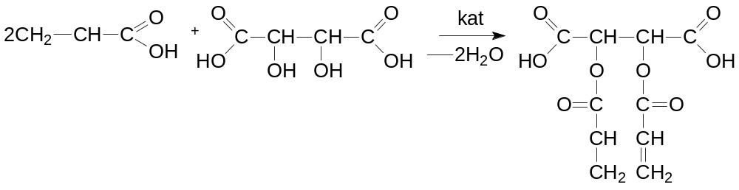
The HPLC analysis showed a single major chromatographic peak at a retention time of 1.557 min. The integrated peak area was 53.43876 mAU·s, corresponding to 100.0% of the total integrated chromatographic area. These results indicate high chromatographic purity of the synthesized DAVE monomer under the applied analytical conditions. The HPLC chromatogram is presented in Figure 1.

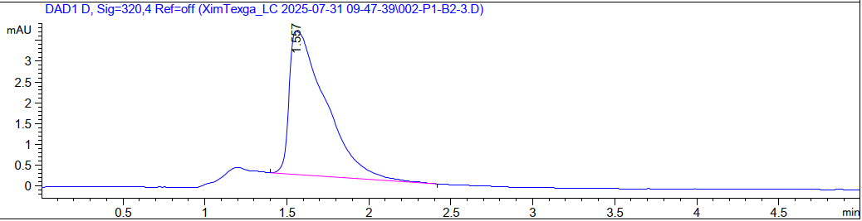

Figure 1: HPLC chromatogram of the synthesized DAVE monomer.
The formation of the DAVE ester structure was confirmed by FTIR analysis.
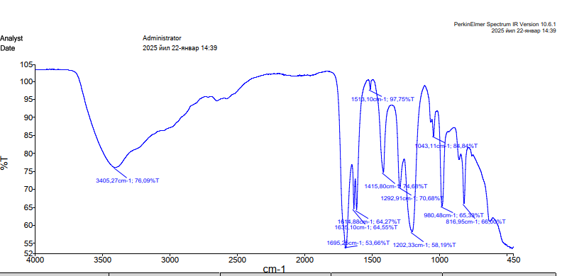
Figure 2: FTIR spectrum of the synthesized DAVE monomer with the principal characteristic absorption bands indicated.
The main FTIR absorption bands were attributed as follows: the band at 1695 cm⁻¹ to C=O stretching vibration; the bands at 1635 and 1614 cm⁻¹ to C=C stretching vibrations; the bands at 1292 and 1202 cm⁻¹ to C–O–C vibrations; and the bands at 977 and 819 cm⁻¹ to vibrations associated with the acrylic C=C bonds. The structure of the synthesized ester was also studied using 1H NMR spectroscopy. In the spectrum, δ=5.34 ppm corresponds to the signals of vinyl protons belonging to the acrylic region. This shift confirms the presence and preservation of acrylic acid in the ether. The absorptions in the δ=4.47 ppm region belong to the –O-CH– and –O-CH₂ protons adjacent to the oxygen atom, serving as the primary confirmation of the formation of the ester bond. The singlet spectral signal of tartaric acid in the range of 3.00–3.36 ppm belongs to the proton of the COOH group. Methylene protons -CH₂, located near the carbonyl group, are expressed in the δ=2.49-2.16 ppm region.
The morphology of the synthesized ether sample observed by using scanning electron microscope (SEM), as shown in Figure 3 a, is irregular and an aggregated structure.
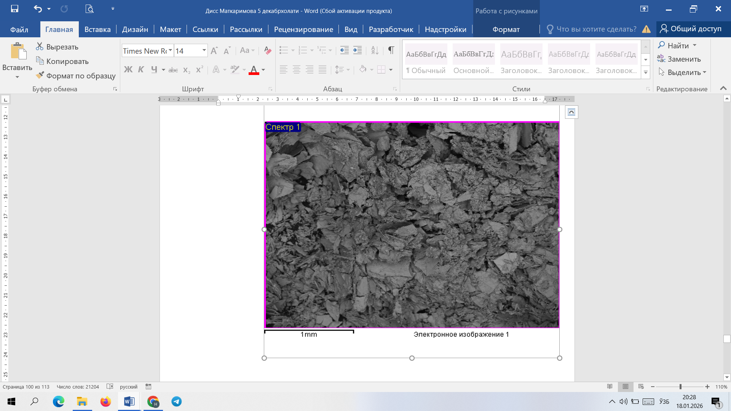 | 
a) | b)
Figure 3: SEM (a) and EDS (b) analysis of synthesised DAVE ester

As shown in figure 2 a, the material is composed of densely packed particles of different sizes and has a layered and porous structure. Particle adhesion during synthesis and drying causes aggregation and an increase in specific surface area.
The principal peaks in the energy-dispersive X-ray (EDS) spectrum are attributed to carbon and oxygen (Figure. 2 b). This confirms the organic nature of the synthesized ester and the presence of ester and carboxyl functional groups. The absence of peaks of other elements proves the high purity of the synthesised product.
3.4 Acute oral toxicity
The experiment was performed on mature (18–22 g) white female mice. The test substance was given orally as a 20% aqueous solution at single doses of 500–4000 mg/kg via a metal gavage probe. Five animals per dose were used and were observed for 14 days. Observations were made on general condition, behavior, response to external stimuli, respiratory activity, motor activity, appearance of hair, skin and visible mucous membranes, food and water consumption, and fecal and urinary excretion during the observation period. They also noted mortality and signs of intoxication. The LD50 was found to be 3,250 mg/kg. Mortality was 20% (1/5 animals) at 3,000 mg/kg and 40% (2/5 animals) at 3,500 mg/kg. At the highest dose tested (4,000 mg/kg), mortality was 100% (5/5 animals). At 2,000 mg/kg, transient excitation and decreased motor activity were seen, which disappeared during the observation period. (Table 1)

Table 1: Acute oral toxicity and mortality of mice following administration of DAVE at different doses
Dose, mg/kg | Number of animals, n | Mortality, n | Mortality, % | Observed response
500 | 5 | 0 | 0 | No mortality
1,000 | 5 | 0 | 0 | No mortality
1,500 | 5 | 0 | 0 | No mortality
2,000 | 5 | 0 | 0 | Transient excitation and reduced motor activity
2,500 | 5 | 0 | 0 | No mortality
3,000 | 5 | 1 | 20 | First lethal effects
3,500 | 5 | 2 | 40 | Increased mortality
4,000 | 5 | 5 | 100 | Complete mortality

No mortality was observed at doses of 500–2,500 mg/kg. At 3,000 mg/kg, mortality was 20% (1/5 animals), while mortality increased to 40% (2/5 animals) at 3,500 mg/kg. At 4,000 mg/kg, mortality reached 100% (5/5 animals). Transient excitation and reduced motor activity were observed at 2,000 mg/kg. These findings demonstrate a dose-dependent acute toxicological response to the synthesized DAVE monomer.

3.5 Local irritation of oral mucosa
In the second stage of the study, the local irritant effect of the di (met) acrylic ether-based dental composite material was evaluated using direct contact methods on laboratory rabbits. 12 clinically healthy animals weighing 2.5–3.0 kg were used in the experiment. Animals were housed under conventional vivarium conditions 5 days before the beginning of the experiment. Samples of the dental composite material under study were prepared in equal sizes under sterile conditions. In experimental groups sterile swab with 0.1 g, 0.2 g and 0.3 g of samples were applied on cheek mucosa of animals for 30 minutes.
Equal-sized samples of the dental composite material under consideration were prepared under sterile conditions. In the experimental groups, +0.1 g, 0.2 g and 0.3 g samples were used. Clinical indicators of the state of the oral mucous membrane were analyzed for quantitative assessment of the local tolerance of the composite material (Table. 2).
The data presented in Table 2 clearly show that in all experimental groups, regardless of the sample weight (0.1–0.3 g), there were no signs of mucosal irritation. The general condition of the animals remained stable, and the survival rate was 100% in all cases. This indicates the absence of local irritant action in the studied composite material.

Table 2: Evaluation of local irritant effect on oral mucosa
Group | Sample weight, g | Number of animals | Irritation symptoms | General condition | Survival rate, %
Control 0 | 0 | 5 | Absent | Unchanged | 100
Expert 1 | 0,1 | 5 | Absent | Unchanged | 100
Expert 2 | 0,2 | 5 | Absent | Unchanged | 100
Experienced 3 | 0,3 | 5 | Absent | Unchanged | 100

As seen from the data in Table 2, no signs of mucosal irritation were observed in all experimental groups, regardless of the sample weight (0.1–0.3 g). The general condition of the animals remained stable, and the survival rate was 100% in all cases, indicating the absence of local irritant action from the studied composite material. For more accurate assessment, a standard scale for the severity of oral mucosal erythema was used (Table. 3)

Table 3. Scoring scale for evaluation of oral mucosal erythema
Erythema and crust formation | Score, points
No erythema observed | 0
Very slight erythema (almost imperceptible) | 1
Clearly distinguishable erythema | 2
Moderate to severe erythema | 3
Severe erythema with eschar formation | 4

The response of the oral mucosa was evaluated by means of the erythema scoring scale presented in Table 3. A score of 0 meant no erythema, whereas higher scores indicated increasing severity of mucosal erythema and tissue reaction. In the present study, the irritation score was 0, indicating that no erythema or edema was observed in any of the experimental groups.The biological safety of DAVE should be interpreted considering the limitations of the present study. Biological testing was limited to acute oral toxicity and local mucosal irritation. In the present work, cytotoxicity testing with adequate dental cell models, residual monomer release measurement and further in vitro biocompatibility studies were not performed. These investigations are required for a more complete evaluation of suitability of DAVE for dental applications and should be included in future studies. The present results can therefore be regarded as preliminary evidence of acute biological tolerance, but not as definitive evidence of long-term biocompatibility.

4. CONCLUSIONS
A new tartaric-acrylic ester monomer (DAVE) and an inorganic-filled dental composite were developed and tested for their toxicological safety and biocompatibility in the oral environment. The esterification reaction at 80 ± 2 °C (1:2 molar ratio) gave high yield of 86% and chromatographic and IR analyses confirmed the high purity and correct structure of the synthesized monomer. Low toxicity was observed in acute oral toxicity tests in mice. Short-term respiratory discomfort and restlessness were observed at 1000–1500 mg/kg, without mortality. Reversible excitation was observed at 2000 mg/kg, the first lethal dose was 3000 mg/kg and 100% mortality was seen at 5000 mg/kg. The calculated LD₅₀ = 3720 mg/kg, which indicates hazard class IV. Solutions of 0.5–1.0% produced no toxic effects and even at 5.0% only mild. Local effects in rabbits were examined and no irritation of oral mucosa was observed after application of 0.1-0.3 g composite samples for 30 min. No erythema and edema were observed, and the survival rate of all groups was 100% (irritation score 0 points). In general, the synthesized DAVE monomer and its composite have shown low acute toxicity, the absence of local irritation and high biological safety, which confirms the prospects of their use as a promising organic matrix for dental composite materials.
  - REFERENCES
Black J., 2005, Biological Performance of Materials: Fundamentals of Biocompatibility, CRC Press, doi.org/10.1201/9781420053940
Chatzistavrou X., Velamakanni S., DiRenzo K., Lefkelidou A., Fenno J.C., Kasuga T., Boccaccini A.R., Papagerakis P., 2015, Designing dental composites with bioactive and bactericidal properties, Materials Science and Engineering C, 52, 267–272, doi.org/10.1016/j.msec.2015.03.062
Cheng L., Weir M.D., Xu H.H.K., Antonucci J.M., Kraigsley A.M., Lin N.J., Lin-Gibson S., Zhou X., 2012, Antibacterial amorphous calcium phosphate nanocomposites with a quaternary ammonium dimethacrylate and silver nanoparticles, Dental Materials, 28(5), 561–572, doi.org/10.1016/j.dental.2012.01.005
Imazato S., 2003, Antibacterial properties of resin composites and dentin bonding systems, Dental Materials, 19(6), 449–457, doi.org/10.1016/S0109-5641(02)00102-1
Kirkpatrick C.J., Bittinger F., Wagner M., Köhler H., van Kooten T., Klein C.L., Otto M., 1998, Current trends in biocompatibility testing, Proceedings of the Institution of Mechanical Engineers Part H: Journal of Engineering in Medicine, 212(2), 75–84, doi.org/10.1243/0954411981533903
Krifka S., Spagnuolo G., Schmalz G., Schweikl H., 2013, Adaptive mechanisms in cell responses to oxidative stress caused by dental resin monomers: A review, Biomaterials, 34(19), 4555–4563, doi.org/10.1016/j.biomaterials.2013.03.019
Kuksenok V.Yu., Shtrykova V.V., 2023, Laboratory Practical Training in Organic Chemistry, Tomsk Polytechnic University
Mahmudova F., Maksumova A., Matkarimova N., Tadjieva Sh., Latipova I., 2023, Study of the reaction of olefins with acetic acid, E3S Web of Conferences, doi.org/10.1051/e3sconf/202340214020
Matkarimova N.S., Maksumova O.S., 2025, Synthesis of an ester based on bio-derived dicarboxylic acids and its prospects, Universum: Chemistry and Biology, 12(138), doi.org/10.32743/UniChem.2025.138.12.21414
Matkarimova N.S., 2026, Rheological properties and thickening ability of a copolymer based on itaconic and (meth)acrylic acids, Universum: Chemistry and Biology, 4(142), Available at: 7universum.com/ru/nature/archive/item/22371
Mjör I.A., 1992, Side effects of dental restorative materials, International Dental Journal, 42(1), 9–15, doi.org/10.1111/j.1875-595X.1992.tb00786.x
Scott A., Egner W., Gawkrodger D.J., 2004, Occupational allergic contact dermatitis in dentistry, Contact Dermatitis, 50(2), 83–87, doi.org/10.1111/j.0105-1873.2004.00306.x
Shahi S., Özcan M., Maleki Dizaj S., Sharifi S., Al-Haj Husain N., Eftekhari A., Ahmadian E., 2019, Potential toxicity of dental materials and screening of their biocompatibility: A review, Toxicology Mechanisms and Methods, 29(5), 368–377, doi.org/10.1080/15376516.2019.1566424
Williams D.F., 1999, The Williams Dictionary of Biomaterials, Liverpool University Press, doi.org/10.5949/liverpool/9780853239273.001.0001
Zhang K., Zhang N., Weir M.D., Reynolds M.A., Bai Y., Xu H.H.K., 2017, Bioactive dental composites and bonding agents with remineralizing and antibacterial characteristics, Dental Clinics of North America, 61(4), 669–687, doi.org/10.1016/j.cden.2017.05.002

